**Module – 4 [ Automation Core Testing ]**

(Load Runner Up)

* **Which components have you used in Load Runner?**

**Virtual user generator (VUGEN)**

* It records Vuser scripts that emulate the step of real users using the application.

**Controller**

* It is an administrative center for creating ,maintaining ,and executing scenarios .starts and stops load tests, and perform other administrative tasks

**Analyser**

* Uses the load test results to create graphs and reports that are used to correlate system information and identify both bottlenecks and performance issues.
* **How can you set the number of Vusers in Load Runner?**
* You can set the number of Vusers in the controller section while creating your scenarios. Many other advanced options like ramp-up, ramp-down of Vusers are also available in the Controller section.
* **What is Correlation?**
* Correlation is a critical process in performance test scripting.
* You can ignore correlation only if you are testing direct pages e.g. if you are testing only the home page load, contact page load, pricing page load etc., then you cannot perform correlation.
* Correlation is important when you are dealing with session IDs, date and time in milliseconds, dynamic values in the URLs, responses, headers etc.
* **What is the process for developing a Vuser Script?**
* Step 1- Record the Vuser Script.
* Step 2- Playback and improve the recorded vuser script.
* Step 3- Define and test the different run-time parameters.
* Step 4- Use the script in a LoadRunner scenario.
* **How Load Runner interacts with the application?**
* Load Runner simulates user activity by generating messages between application components or by simulating interactions with the user interface such as key presses or mouse movements. The messages and interactions to be generated are stored in scripts.
* **How many VUsers are required for load testing?**
* if you run a load test with 10,000 virtual users, each making a request every 20 seconds (3 requests per minute), then you're making 30,000 requests per minute, which equals 500 requests per second.
* **What is the relationship between Response Time and Throughput?**
* Response time and throughput are related. The response time for an average transaction tends to decrease as you increase overall throughput. However, you can decrease the response time for a specific query, at the expense of overall throughput, by allocating a disproportionate amount of resources to that query.
* **What is the difference between hits/second and requests/second?**
* Hits per second means the number of hits the server receives in one second from the vuser. Request per second is the number of request the vuser will request from the server.
* **create a normal script of above website with correlate using hp default website.**

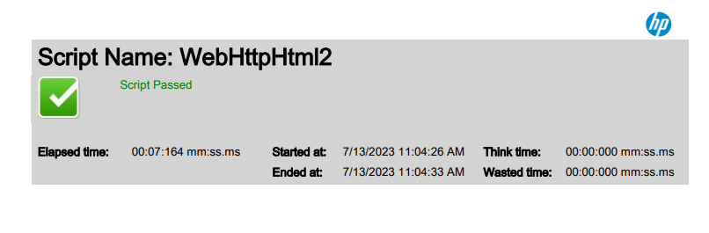

**Selenium (IDE)**

* **What is Automation Testing?**
* Automation Testing is a software testing technique that performs using special automated testing software tools to execute a test case suite.
* **Which Are The Browsers Supported By Selenium Ide?**
* Selenium IDE has add-ons for Firefox and Chrome browsers. Selenium IDE comes with a rich set of commands that are powered by Selenese, and it allows you to record and test different interactions of a web application with the browser.
* **What are the benefits of Automation Testing?**
* 70% faster than the manual testing
* Wider test coverage of application features
* Reliable in results
* Ensure Consistency
* Saves Time and Cost
* Improves accuracy
* Human Intervention is not required while execution
* Increases Efficiency
* Better speed in executing tests
* Re-usable test scripts
* Test Frequently and thoroughly
* More cycle of execution can be achieved through automation
* Early time to market
* **What are the advantages of Selenium?**
* It plays a critical role in metabolism and thyroid function and helps protect your body from damage caused by oxidative stress. What's more, selenium may help boost your immune system, slow age-related mental decline, and even reduce your risk of heart disease.
* **Why testers should opt for Selenium and not QTP?**
* Selenium can run tests in parallel with Selenium Grid. QTP cannot run tests in parallel by itself, and another commercial tool called HP Quality Center or QC is needed. Selenium supports web applications only. QTP can run tests for both desktop and web applications.
* **Selenium :**

**https://github.com/Foram-77/Foram_Testing_Tops/tree/main/Assignments/Module%204**